- What is software testing, and why is it important? [slide 9&10]
Software testing is the process of exercising or evaluating a system or component by manual or automated means to verify it satisfies specified requirements. It is also defined as the process of executing a program with the intent of finding errors
Important:
- Quality Assurance: Ensures the product meets or exceeds customer expectations, leading to better user experiences.
- Risk Reduction: Identifies bugs early to prevent failures in live environments, which could damage a brand's reputation.
- Cost Efficiency: Detecting and fixing defects during development is significantly cheaper than after the product is released.

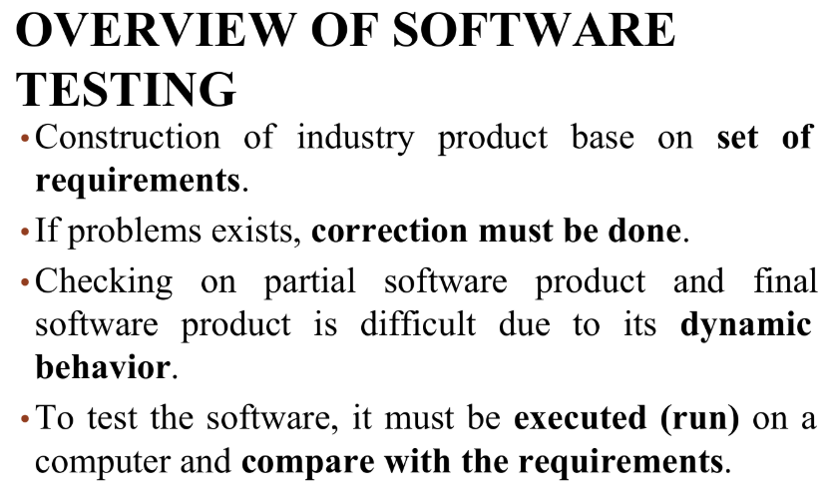

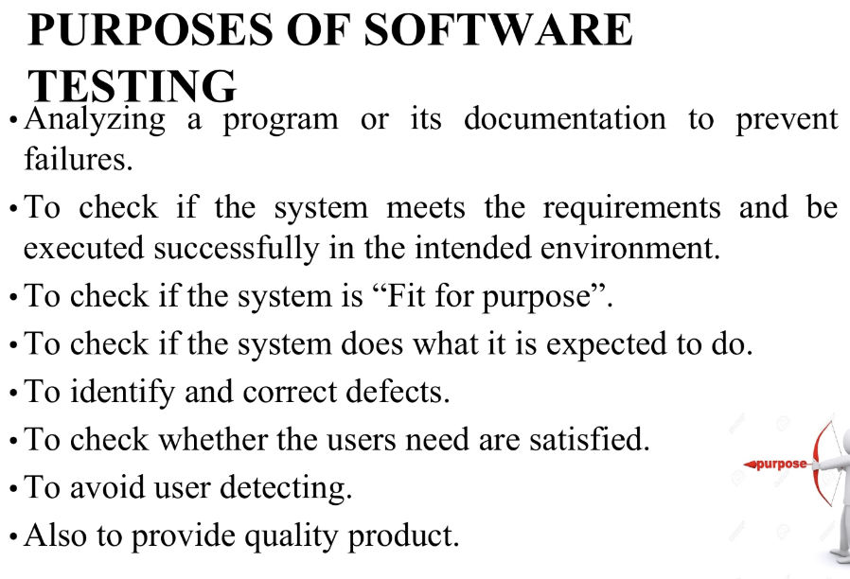
Consequences if testing activities are not performed
- Excessive expenses (High failure cost - direct and indirect cost)
  - Software bugs require prompt attention to rectify. This is easy during pre-launch testing, especially when conducting agile testing, or continuous testing that is concurrent with software development. However, bug remedies become increasingly difficult the more deeply ingrained into the software they become. The cost to fix bugs or defects post-development is a significant consideration associated with improper software testing. These costs may include long work hours, lost productivity and profit loss during software downtime.
- Dissatisfied users
  - Software users have certain expectations about the products they use; they expect them to run fast, work properly, and protect their private information. If software bugs prevent them from having a positive user experience (UX), they will likely churn perhaps never to return. Notably, poor user experiences are more likely to garner negative public feedback than positive experiences.
  - What worse : negative feedback could block potential leads from ever trying the software in the first place
- Reduce brand / organization’s reputation
  - A bad experience from the users will lead to ripple effects. They will perceive the brand as negative after having a negative experience (and may “announce” the experience to the world). This is will lead to company’s and reputation, and as chain effect, the company may experience financial loss

- Recall the principles of software testing. [slide 23]
- Testing shows the presence of defects, not their absence: Testing can prove bugs exist but cannot prove the software is 100% bug-free.
- Exhaustive testing is impossible: Testing every single combination of inputs and preconditions is not feasible.
- Early testing: Testing should start as early as possible in the life cycle to save time and money.
- Defect clustering: A small number of modules usually contains the majority of defects.
- Pesticide paradox: Repeating the same tests will eventually stop finding new bugs; test cases must be regularly updated.
- Testing is context-dependent: Testing is performed differently based on the type of software (e.g., a medical app vs. a game).
- Absence-of-errors fallacy: Fixing bugs is useless if the system is unusable or does not meet the user's actual needs.
6. The Seven Principles of Testing
1. Testing shows the presence of defects, not their absence
- Description: Testing is designed to prove that the product fails (i.e., that there are defects).
- Key Concept: It reduces the probability of hidden defects but cannot prove a program is 100% defect-free. Even if no failures are found, it is not proof that the software is perfect.
- Example: A software team rigorously tests an e-commerce application and finds no critical defects. However, after launch, customers report issues when using a rare combination of a specific browser and payment method.
2. Exhaustive testing is impossible
- Description: It is impossible to run an exhaustive test that includes every possible value for every input and all possible combinations of preconditions.
- Key Concept: In normal practice, exhaustive testing would require an "astronomically" high number of test cases. Therefore, every test is just a sample.
- Example: A flight booking system allows users to search by date, location, airline, and price range. Testing all possible combinations would take years, so testers focus on high-impact areas like peak travel dates and boundary conditions.
3. Testing activities should start as early as possible
- Description: Testing should begin early in the software life cycle and focus on defined goals.
- Key Concept: Starting early contributes to finding defects sooner, which saves time and money.
- Example: In a mobile banking app, if a security vulnerability is found during early unit testing, it costs much less to fix than if it were found later during User Acceptance Testing (UAT) or after release.
4. Defect clustering
- Description: Defects are not evenly distributed; they tend to cluster together.
- Key Concept: Most defects are found in a small number of modules. If many defects are detected in one place, there are likely more nearby.
- Example: A video streaming platform finds that 80% of user complaints come from just two specific features: video playback and payment processing. Testers should react flexibly and focus more effort on these areas.
5. The pesticide paradox
- Description: If the same tests are repeated over and over, they lose their effectiveness and stop discovering new defects.
- Key Concept: Just as insects become resistant to pesticides, software becomes "resistant" to a static set of tests. New and modified test cases must be added.
- Example: A ride-sharing app uses the same regression tests for six months and finds no bugs. However, when testers introduce new edge cases like surge pricing or rare route scenarios, several critical bugs are discovered.
6. Testing is context dependent
- Description: Testing must be adapted to the specific risks, usage, and environment of the application.
- Key Concept: No two systems should be tested in exactly the same way. The intensity and exit criteria depend on the software's purpose.
- Example: Medical software used for patient monitoring requires extensive regulatory compliance testing because of life-threatening risks. In contrast, a food delivery app follows a lighter test process.
7. Absence-of-errors fallacy
- Description: The belief that finding and repairing defects guarantees a successful system is a mistake.
- Key Concept: No failures found does not automatically mean the system is useful; it must still meet user expectations and needs.
- Example: A messaging app is launched with zero known bugs, but users find the interface confusing and the message delivery too slow. Despite being technically "error-free," it fails because it doesn't satisfy user needs.

- Software testing is unavoidable when developing the software. Some said software testing is an “umbrella activity”. Analyse the reason behind.
An umbrella activity is one that is performed throughout the entire software development process, rather than being confined to a single phase. Analysis:
- Testing is not just a "final step" but spans from Requirement Analysis to Deployment.
- It supports and controls quality across all primary engineering tasks.
- It provides continuous feedback loops and risk management throughout the life cycle.
Yes, software testing is an activity of SQA process as it occurs at several stages in the development. Software testing is also part of the development process of SDLC
Yes, software testing is an activity of SQA process as it occurs at several stages in the development. Software testing is also part of the development process of SDLC. Software testing is considered an "umbrella activity" because it is integrated throughout the Software Development Life Cycle (SDLC) rather than being a separate phase. It ensures quality at every stage, from requirement analysis to deployment, by detecting defects early and reducing the cost of fixes. Testing involves multiple stakeholders, including developers, testers, and end-users, who contribute to different testing types such as unit, integration, and user acceptance testing (UAT). Since software testing covers a wide range of activities, including functional, security, and performance testing, it adapts to various needs throughout development. Ultimately, its continuous nature and broad scope make software testing a critical and ongoing process in software development.

4. Early testing is one of the principles of software testing, throughout the software
development life cycle, identify what artifacts will be tested after the Analysis, Design, Coding and Implementation stage.
Analysis Stage: Program documentation and project requirements.
Design Stage: Test design specifications and test case specifications.
Coding Stage: Source code (technical aspect of testing).
Implementation Stage: The partial and final software product, including test procedures and the built environment.
SRS - Software/System Requirements Specification
SDD - Software Design Document
Coding - Source Code
Implementation - Source Code / Functional System
5. Different systems cannot have the same way of testing? Do you agree? Justify your
points.
Yes, I agree.
Testing must be adapted to the risks inherent in the use and environment of the application. For example, medical software for patient monitoring requires extensive regulatory compliance, whereas a food delivery app follows a lighter process because it lacks life-threatening risks.
Yes, due to different systems may have different functions or requirements to be fulfilled.
Test criteria is different for different system

6. Explain the relationship between Error, Defect and Failure.
Error: A mistake by a person, such as bad programming.
Defect (Fault): An incorrect internal state or "bug" present in the software from the time it was developed.
Failure: When a requirement is not fulfilled or there is a discrepancy between actual and expected results during execution.
The Chain: An error leads to a fault, and a fault may eventually manifest as a failure when executed.
slide 19
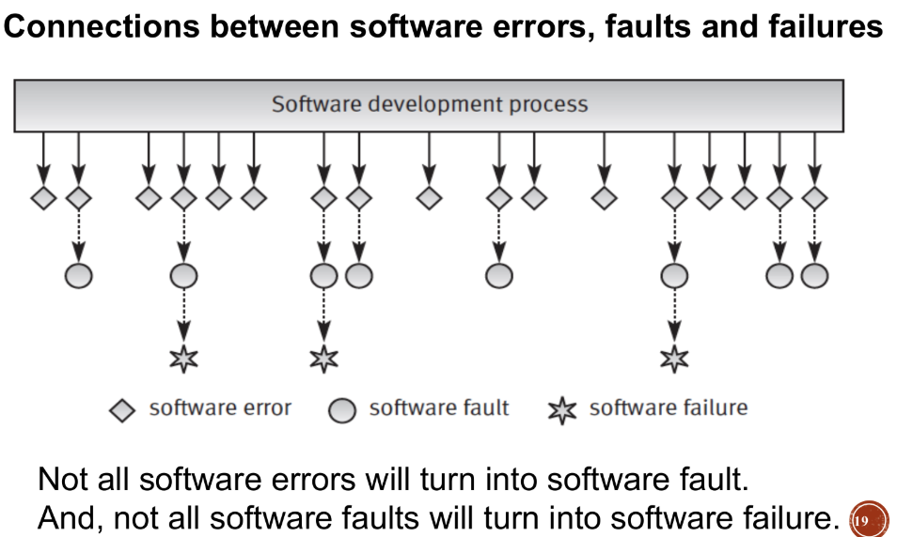

7. Define verification and validation in software testing. How do they differ?
Verification: The process of determining whether products of a given phase fulfill requirements from the previous phase ("Are we building the system right?").
Validation: Evaluating software at the end of development to ensure compliance with intended usage ("Are we building the right system?").
Slide 20
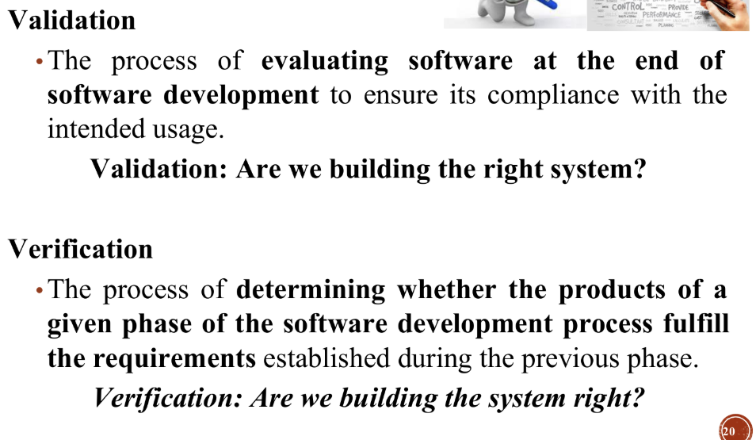

8. How do developers, testers, and users conduct a software test differently?
Testers (Software Test Engineers): Charge of technical activities like designing inputs, running scripts, and reporting results to managers.
Developers (Programmers): Often focus on identifying errors they can fix during construction.
End-Users: Involved to ensure needs are satisfied and to avoid "detecting" failures after release; they test the software for "fitness for purpose".
Tester | Developer | End User
Focused on writing and debugging the code.  Typically perform unit testing, integration testing, and debugging their own code | Ensure the software meets requirements and is defect-free  Perform functional, regression, performance, usability and exploratory testing  May not have deep knowledge of the codebase, so they rely on test specification and user stories | Use the software real world tasks  Perform User Acceptance Testing (UAT), exploratory testing, and real world testing  Not technical, so they may not identify the root cause of issues but can highlight usability concerns

9. Why some defects in the software will not turn into failure. Explain with one
example.
Not all software faults will turn into software failure.
Example: A fault might be present in the code, but if that specific part of the software is never executed or the specific conditions to trigger it are never met, no failure occurs.
There is possible for defects that not lead to failure
For example, A programmer had written incorrect code in a condition statement and this statement. Did not bring any effects to the result or has no possibility to be executed

10. When performing testing, some tests have a higher priority than others. What are the criteria to be considered in prioritizing the tests?
Risk: Adapt testing to the risks inherent in the environment.
Context: Usage environment dictates the intensity of testing.
Impact: Serious-level impacts like financial cost or life-death matters take precedence over low-level inconveniences.
- The importance of the functions
- Time
- The test case may require another test to be performed before it can be executed

- Importance of the Functions – Key functionalities essential for the software to operate must be tested first, as failures in these areas could significantly impact users and business operations.
- Time Constraints – Tests must be prioritized based on time-sensitive requirements, ensuring critical functionalities are verified before tight deadlines or releases.
- Test Dependency – Some tests rely on the execution of other test cases before they can be performed. Dependencies must be considered when determining the test execution order to avoid invalid or incomplete testing.

11. Explain how the Software Testing Life Cycle (STLC) is different from the Software Development Life Cycle (SDLC).
SDLC (Development): Focused on the overall construction and development process.
STLC (Testing): A planned and systematic approach specifically for testing software to ensure quality, functionality, and security. It focuses on checking the product against requirements

Aspect | STLC | SDLC
Focus  Involves  Goal | Software testing  QA/Tester  Ensure quality of the product | Entire Software Development  Developers, Business Analysts, QA  Build and deliver working software

12. Based on your understanding, why is STLC important?
Efficiency: It helps optimize the testing process.
Organization: It ensures systematic requirement analysis, environment setup, and execution to find defects.
Documentation: It provides necessary deliverables (test plans, logs, reports) to stakeholders to prove the quality of the product.
- Ensures thorough testing and defect detection
- Bring structure and clarity to testing activities
- Helps in early bug detection, reducing cost and time

Ensures thorough testing and defect detection
STLC provides a systematic and structured approach to testing, ensuring that every feature, module, and requirement is validated. By following well-defined phases-such as test planning, test design, test execution, and test closure-testers can identify defects comprehensively rather than testing randomly. This thoroughness helps uncover both functional and non-functional issues before the software is released.
Brings structure and clarity to testing activities
STLC breaks down the testing process into clear, manageable stages with specific goals, deliverables, and responsibilities. This structured approach improves coordination within the QA team, ensures consistency, and prevents confusion or missed steps. Each phase has defined entry and exit criteria, helping teams stay organised and aligned with project expectations.
Helps in early bug detection, reducing cost and time
One of the major advantages of STLC is that testing begins early, especially from the requirement analysis stage. Detecting bugs earlier in the life cycle is far less costly than fixing them during deployment or after release. Early detection also reduces the time spent in rework and prevents defects from snowballing into bigger issues later.
Improves software quality and reliability
A well-executed STLC ensures that the final product is stable, reliable and meets user expectations. It helps validate not only that the software works, but that it works well under various conditions, enhancing overall user satisfaction

